 | curriculum.newvisions.org/social-studies  Timothy Lent - tlent@newvisions.org  Kameelah Rasheed - krasheed@newvisions.org | 
Please Read: We encourage all teachers to modify the materials to meet the needs of their students. To create a version of this document that you can edit:  1. Make sure you are signed into a Google account when you are on the resource.  2. Go to the "File" pull down menu in the upper left hand corner and select "Make a Copy." This will give you a version of the document that you own and can modify. |  | 
Teacher Overview: Where was the Ottoman Empire? How interconnected was it to other regions?
Go directly to student-facing materials!

 | 9.6 Vocabulary Opener | SQ 1. Where was the Ottoman Empire? How interconnected was it to other regions? | SQ 2. What was the historical context for the founding of the Ottoman Empire? | 

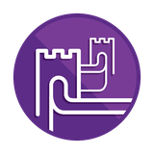 | Unit Essential Question(s): How did the Ottoman Empire and Ming Dynasty gain, consolidate, and maintain power? | Link to Unit
Supporting Question(s):
- What was the geographic context for the founding of the Ottoman Empire?
Objective(s):
- Describe the geographic context for the founding of the Ottoman Empire.

1. NYS Social Studies Framework:
Key Idea | Conceptual Understandings | Content Specifications
9.7 THE OTTOMAN EMPIRE AND THE MING DYNASTY PRE-1600: Islam, Neo-Confucianism, and Christianity each influenced the development of regions and shaped key centers of power in the world between 1368 and 1683. The Ottoman Empire and the Ming Dynasty were two powerful states, each with a view of itself and its place in the world. (Standards: 2, 3, 4, 5; Themes: ID, MOV, GEO, SOC, GOV, EXCH) | 9.7a Three belief systems influenced numerous, powerful states and empires across the Eastern Hemisphere. | Students will map the extent of the Ottoman Empire and the Ming Dynasty at the height of their power.  Students will map the extent of the Muslim, Neo-Confucian, and Christian realms and compare the relative size and power of these realms ca. 1400.

2. Social Studies Practices
NYS Social Studies Practices | New Visions Student Social Studies Practices
Gathering, Using and Interpreting Evidence (A5, A7)  Chronological Reasoning and Causation (B1)  Comparison and Contextualization (C3, C5, C6)  Geographic Reasoning (D1, D2, D5) |  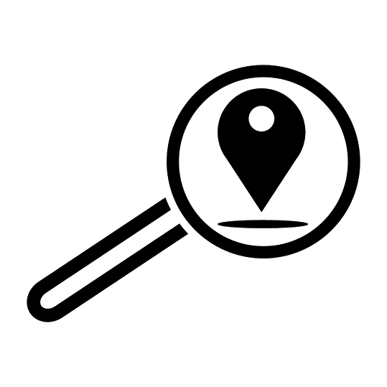  Predict Contextualize Think Like a Geographer

3. Common Core
Reading | Writing | Speaking and Listening
Craft and Structure:  CCSS.ELA-LITERACY.RH.9-10.4: Determine the meaning of words and phrases as they are used in a text, including vocabulary describing political, social, or economic aspects of history/social science.  Integration of Knowledge and Ideas:  CCSS.ELA-LITERACY.RH.9-10.7: Integrate quantitative or technical analysis (e.g., charts, research data) with qualitative analysis in print or digital text. | Text Types & Purposes:  CCSS.ELA-LITERACY.WHST.9-10.1: Write arguments focused on discipline-specific content. | Comprehension and Collaboration:  CCSS.ELA-LITERACY.SL.9-10.1: Initiate and participate effectively in a range of collaborative discussions (one-on-one, in groups, and teacher-led) with diverse partners on grades 9-10 topics, texts, and issues, building on others' ideas and expressing their own clearly and persuasively.

Associated Classroom Posters
Student Social Studies Practices Poster

Objective: | Where was the Ottoman Empire? How interconnected was it to other regions?  - Describe where the Ottoman Empire is located and their interconnectedness to other regions.
Introduction
➡Directions: Label the continents, regions, and bodies of water listed on the map below.
Continents |  | Regions |  | Bodies of Water
Asia | Africa | Middle East | North Africa | Mediterranean Sea | Indian Ocean
Europe |  | Southern Europe |  | Black Sea
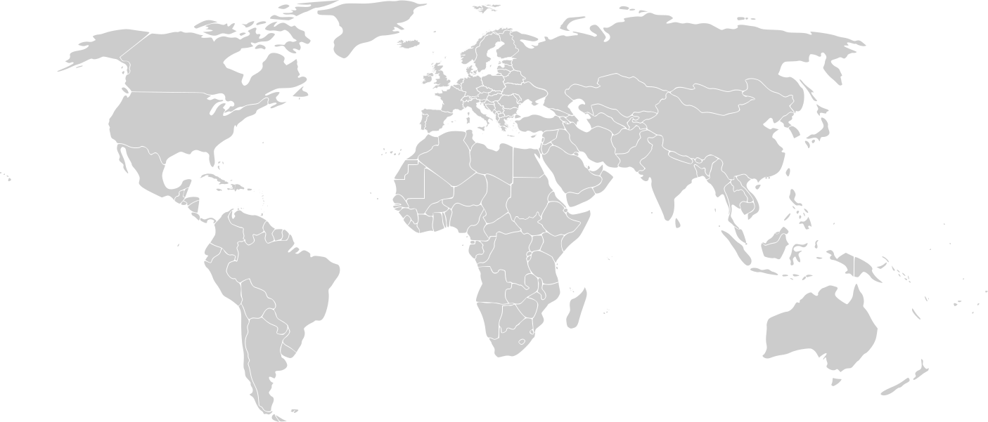
Original image is in the public domain

Where was the Ottoman Empire (1683 CE)? How interconnected was the Ottoman Empire?
➡ Directions: Examine the maps of the Ottoman Empire, then answer the questions that follow.
Think Like a Geographer  Contextualize | 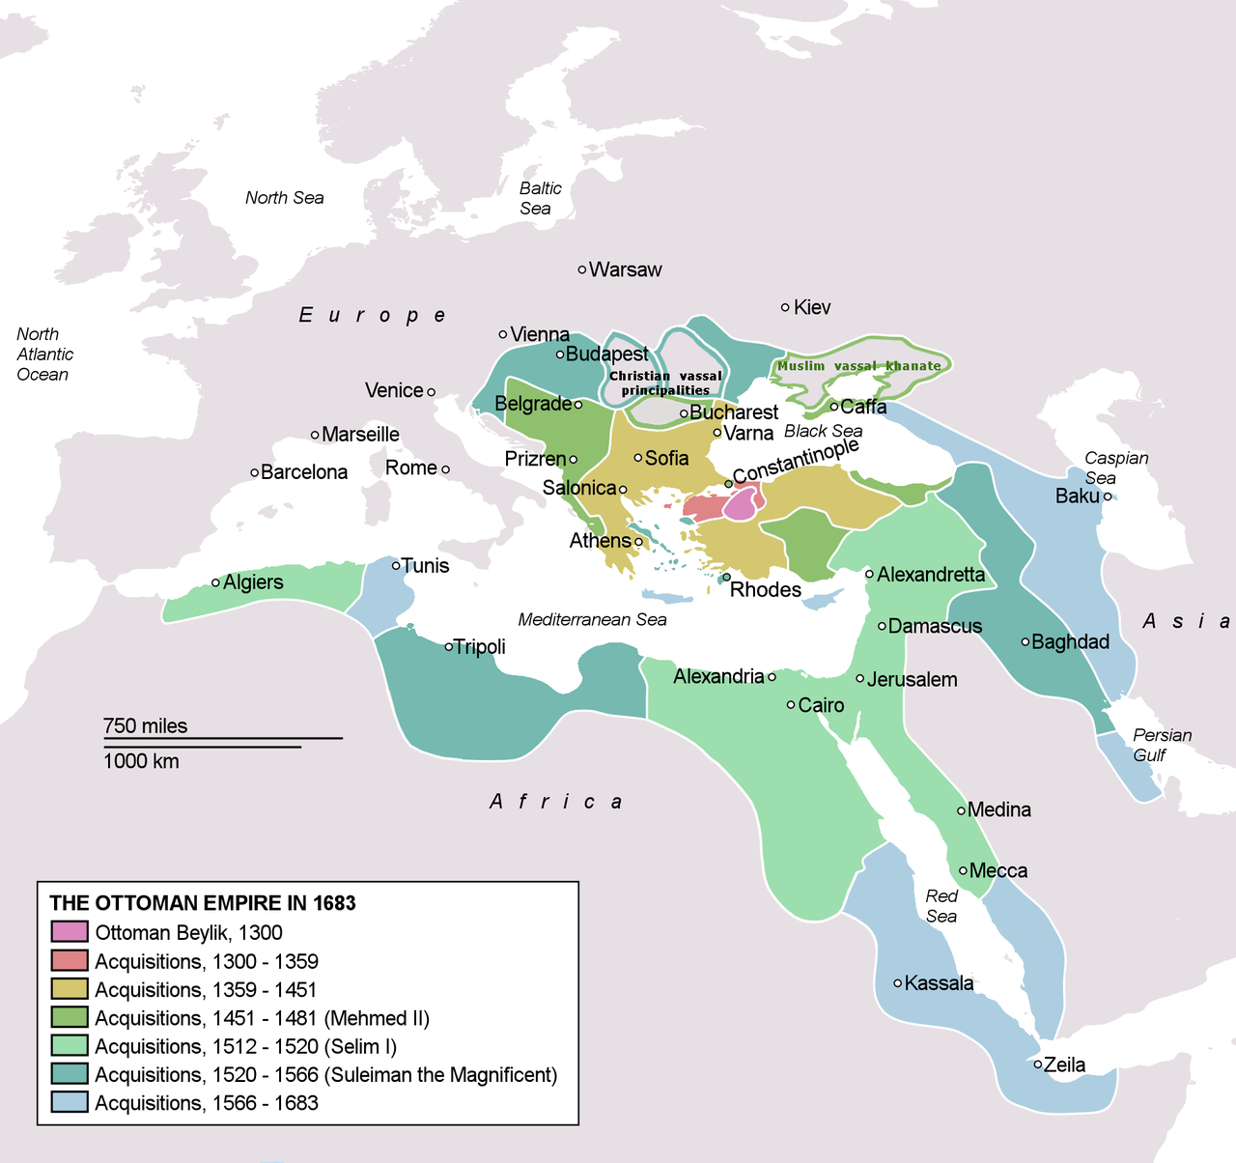  Image is courtesy of Wikipedia Commons and its public domain.

Relative location is a description of where a place is in relation to how a place is related to other places. For example, Canada is north of the state of New York.
North | East | West | South | West | South | Northeast | Northwest

Using the map and directional words above, complete the tasks below.

1. Identify the three continents on which the the Ottoman Empire existed.

2. Describe the location of the the Ottoman Empire to two regions.
3. Describe the location of the Ottoman Empire relative to one ocean.

4. Describe the location of the Ottoman Empire relative to two other bodies of water.

➡ Directions: Examine the images below, then complete the questions that follow.
Think Like a Geographer | 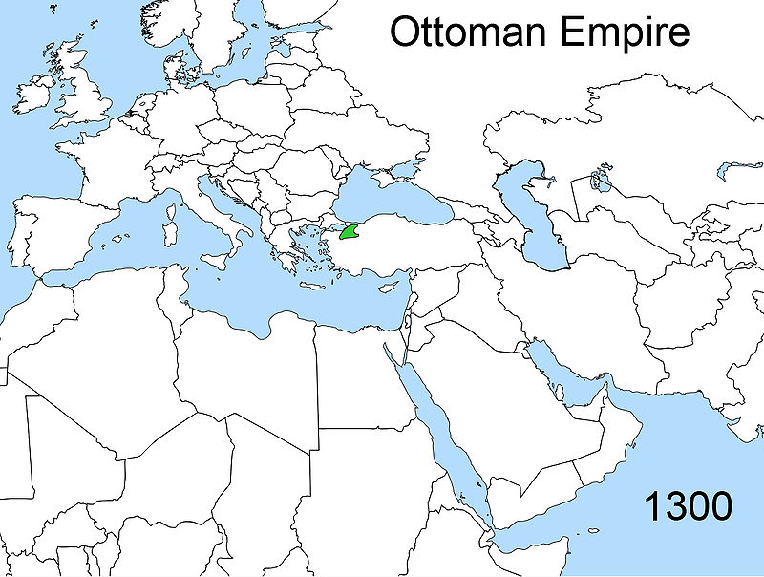  Map is courtesy of Wikimedia Commons and is public domain. | 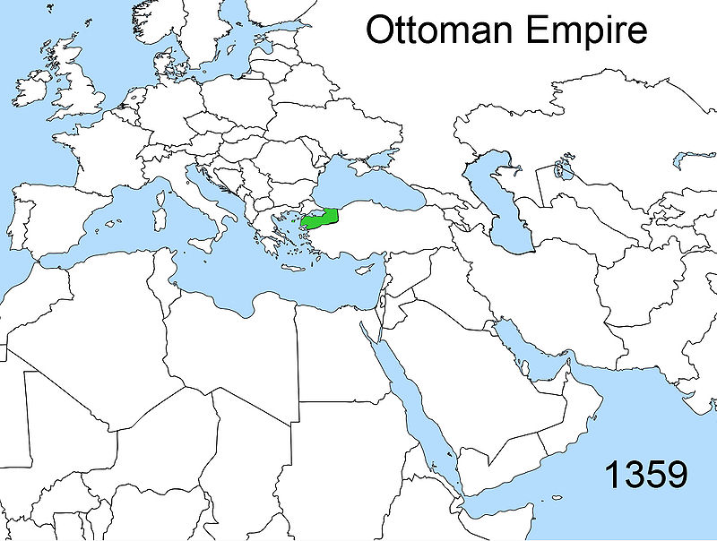  Map is courtesy of Wikimedia Commons and is public domain. | 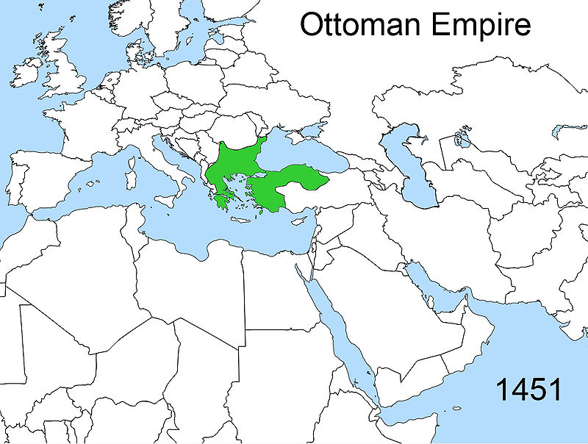  Map is courtesy of Wikimedia Commons and is public domain.
 | 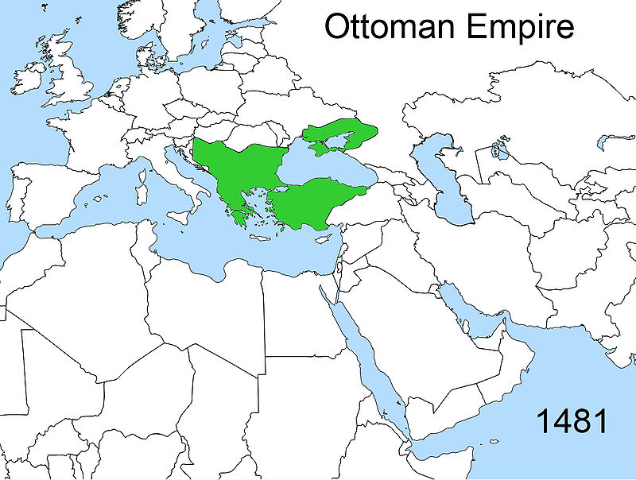  Map is is courtesy of Wikimedia Commons and is public domain. | 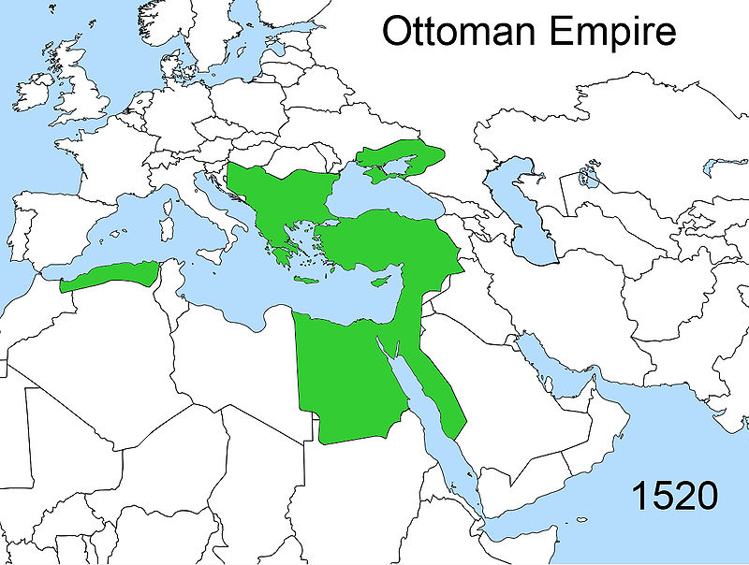  Map is is courtesy of Wikimedia Commons and is public domain. | 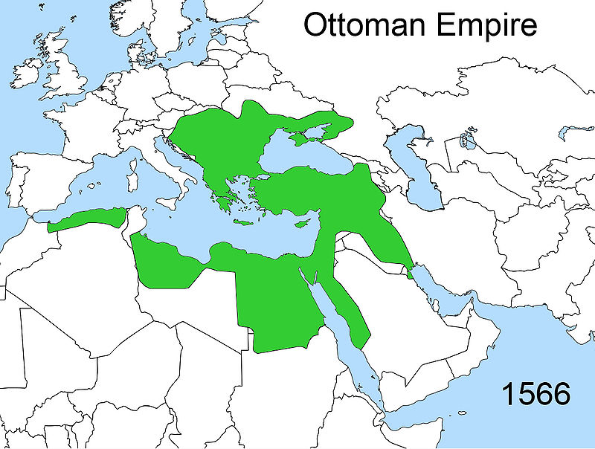  Map is is courtesy of Wikimedia Commons and is public domain.
See  List three things you see in the maps above. | Think  Based on your observations, what do you think caused the changes in the maps above. | Wonder  Write two questions you have about the maps above.

Predict | Based on your knowledge of previous empires, how do you predict the Ottoman empire was able to gain control of large territories across three continents?

FA | SQ 1. Where was the Ottoman Empire? How interconnected was it to other regions?
Think Like a Geographer  Contextualize | Task 1:  Relative location is a description of where a place is in relation to how a place is related to other places.  Using the maps above, write one sentence to describe the relative location of the Ottoman Empire using the bank of cardinal directions below. For example, Canada is north of the state of New York.  North South East West  Northeast Southeast Northwest Southwest  Task 2:  Describe how the Ottoman Empire’s territory changed between 1300 and 1566.

